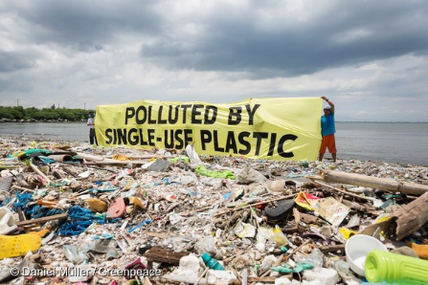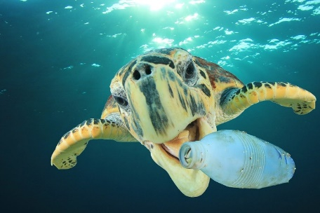**Plastic Pollution Design Problem**

Mr. Poliszuk

|  |  |
| --- | --- |
| **Design, draw, and present a solution that will clean the world's oceans of plastic pollution.** | |
|  | |
| **Explain how your design works to clean the oceans!** | |
|  | |
| **Research and identify what I can do to help reduce plastic waste.** | |
| 1.)  2.)  3.)  4.)  5.) | 6.)  7.)  8.)  9.)  10.) |

Technology 7

East Lower School – Rochester City School District